March 29, 2021
J. Mark Ramseyer & Eric B. Rasmusen (ramseyer@law.harvard.edu & erasmuse@indiana.edu)

Suing over Ostracism in Japan: The Informational Logic

Villages in Japan sometimes ostracize people, and sometimes the targets of ostracism sue or complain to criminal prosecutors. But how can a court help the target? And why would it want to intervene? We look at 25 cases and use a game theory model to frame the question. Our answer is that courts can solve informational problems even if using the coercive power of the state is impractical. The social norm (ostracism) and the government institution (the court system) are complements, each making the other work more effectively. The norm provides punishment; the court provides information.
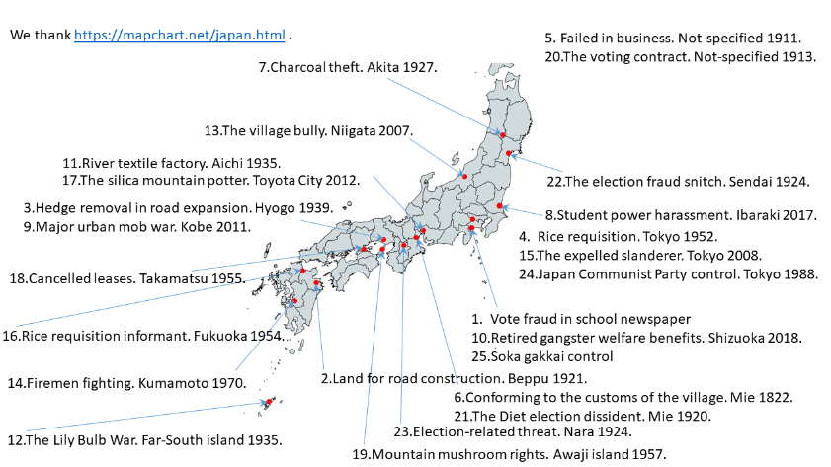

We welcome comments, especially new information on Japanese ostracism court cases and village examples that never went to court.

"murahachibu" (村八分) and "hamon" (破門)

Criminal Code 222: Intimidation. Conduct that would "threaten the life, body, freedom, reputation, or property of another". Section 249 is Extortion (intimidation for money).
Civil Code 709: Torts. "Intentional or negligent invasion of another person's rights or legally protected interests."

The Model.
The target villager chooses to comply with village custom (x = 0) or offend (x = 1). The village sees evidence indicating that the target complied (y = 0) or offended (y = 1). If the target offends, he is always detected: Prob(y=1|x=1) = 1. If he complies, the evidence sometimes mistakenly indicates that he offended: Prob(y=1|x=0) = m, where 0 < m < 1.
If he offends, he obtains personal benefit B > 0 from that act but imposes cost C on the village and D on the rest of society. The village can ostracize the target at cost Z > 0 to itself and cost P > 0 to him.
At cost L to himself, he can go to court. At cost J > 0 to the public, the court can agree to hear it, to decide whether or not the target truly offended, and to announce its decision publicly.
Whether or not the target has gone to court, in the second period the village again chooses whether to ostracize at a second cost Z to itself and P to the target.

(1) No-Penalty Regime: No ostracism, no courts.
(2) Unconstrained Ostracism Regime: Ostracism, courts stay out.
(3) Constrained Ostracism Regime: Ostracism, courts available.

.

