Your name:
Midterm Examination, G406, Fall 2019
Scores: <36: 1.7. 37-38: 2. 39-41: 2.3. 42-46: 2.7. 47-54: 3. 55-58: 3.3. 59-62:3.7. 63-65: 4.

This is a closed-book test. It covers chapters 1 to 6. The test lasts the entire period. Calculators are not allowed, but you may leave difficult calculations unfinished. For any problem with a difficult fraction you can just leave it as a fraction. Each part of each question is worth 3 points in total unless otherwise specified (so a question with parts a and b is worth 6 points). For the short-answer questions (but not the multiple choice) you will receive 1 point if you leave a question blank (or cross out what you’ve written), but 0 points if your answer is poor, and partial credit if your answer is flawed but has some merit.

1. A study by professors at SPEA finds that the cost per life saved from mercury and air toxic standards is $2.8 million while the cost from regulation of new petroleum refineries is $4.6 million. Without specifying a particular value for a statistical life, what does this suggest about ways of improving the regulations? (Kerry Krutilla, David H. Good and John D. Graham
“Uncertainty in the Cost-Effectiveness of Federal Air Quality Regulations,” J. Benefit-Cost Analysis, 2015).
This implies that the marginal cost of increasing the stringency of the mercury regulations is greater than the marginal cost of increasing the stringency of the refinery regulations. If we tightened the mercury regulations to save an additional life and relaxed the refinery regulations to save an additional life, we would have the same number of lives saved, but at lower cost. Thus, we don’t need to know the value of a life--- because we can have the same number of lives saved, but at lower cost, which is clearly better.

2. Let the supply curve be P = Q and the demand curve be P = 24 - 2Q.
(a) If a tax of 3 per unit is imposed on sellers, what is the change in the equilibrium price and quantity?
The original price and quantity are found from Q=P= 12-P/2 so 1.5P = 12 and P = 8 so Q = 8 also.
The new price is found from Q = P-3 = 12 –P/2 so 1.5P =15 and P =10, so Q = 7.

(b) What is the effect on producer and consumer surplus?
Originally, CS = .5(24- 8)(8) = 64 and PS = .5(8-0)*8) = 32.
Then CS = .5(24-10)(7) = 49 and PS = .5(10-3)(7) = 24.5 and tax revenue is 7*3 = 21.
CS has fallen 15, PS has fallen 7.5, and tax revenue has risen by 21.

(c) If the tax of 3 per unit is imposed on buyers instead, what changes in your previous answers?
Nothing changes except that the price is 7 instead of 10. All the surpluses stay the same, as does the quantity.

3. Two economists in Transylvania agree that if nothing is done about global warming, the higher temperature will create benefits of $2 billion per year for the next fifty years for their country because of lower heating costs from winter cold, but it will create costs of $20 billion per year forever from reduced rainfall as the temperature increases further after that. They disagree about the discount rate. One economist would use 1% and the other would use 8%.
(a) Which discount rate do you think is appropriate, and why? (Note: citing to the OMB’s rate for agencies is not a good enough answer)
The argument for the discount rate of 8% is that that is closer to the pretax return on investment in the private sector, so it is better at representing the rate that the private sector requires if an investment is to be undertaken. Thus, the analysis would be using a discount rate that is related to the voters’ individual discount rates and the present value will not just be according to the individual preferences of the economist. If the government adopts projects that only have a 1% return, then it is adopting a project the private sector would reject.
The argument for 1% is that the private sector is wrong, and voters do not care enough about the future. This is plausible (and got full credit), but in that case an even better use of resources than a projecting yielding 1% would be for the government to take invest the present value of the halt in the stock market and let it earn 8% (if that turns out to be correct) and distribute the proceeds in the future.
Some people answered that they want action should be taken to halt global warming, so the 1% discount rate should be used. Indeed, using 1% will help get that conclusion. But if you are actually using the analysis to figure out the present value rather than support a predetermined conclusion that you support for other reasons you should use 1% only if you think that is indeed the right discount rate for all longterm projects, not just the projects you currently favor. You might find an even better policy in which to invest the funds. I did give credit for the answer that “1% gets the analysis to come to the conclusion I want,” since a lot of this course is about how firms lobby for the policies they want, but you should also know how to use the analysis to quantify the actual value.

(b) An international agreement is proposed that would halt global warming immediately without any need for action by Transylvania. What is the present value of that halt according to the economist who uses the 8% discount rate?
If there are benefits of 2 billion per year for the next 50 years, and then costs of 20 billion per year forever, then the value of halting global warming is
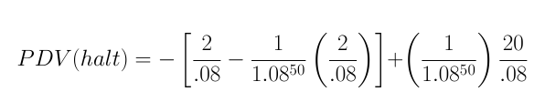

That value is -19, and it would be +1137 if we used the 1% rate.

The first term represents a stream of $2 billion per year for 50 years of benefits from global warming that is lost. The second term represents a stream of $20 billion per year from costs of global warming that is gained, but only starts 50 years from now. Another way to represent this would be as a summation of 50 years of 2 billion lost benefits per year discounted at 8% plus the second term of the above equation.

I also gave full credit for an answer that took the $20 billion costs to start immediately, in which case the value would be
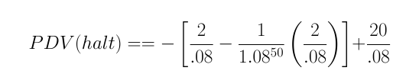

(c) A new estimate, X, replaces the $20 billion figure above. We do not know X. Can we say which economist is more likely to support a geoengineering project in 10 years that would halt global warming?
Having a low discount rate is like being patient. A lower discount rate makes any project with early costs and later benefits look good. Here, the geoengineering project will be an early cost, and the saving of X per year forever will be a later benefit.

4. Why after 2000 did the .08 standard for blood alcohol cause fatalities to increase, instead of to fall as expected?
Police used their resources for roadblocks to catch people with .09 levels who were not tipsy enough to cause accidents, and used fewer resources going after the truly dangerous ones with levels of .15.

5. Why is the equilibrium price where quantity demanded equals quantity supplied?
If the price were anything else, it would not be stable. If quantity demanded exceeded quantity supplied, then any seller would have an incentive to raise his price, because he could still get buyers. If quantity demanded were less than quantity supplied, then some sellers would have incentive to reduce their prices, because otherwise they could not find a buyer but if they did, they could still earn more surplus.
It is NOT a good answer to say “because that would be inefficient” or “because there would be excess demand or supply.” You needed to give a reason why such a price would be the equilibrium, not why it would be nice for it to be the equilibrium.

6. (a) The supply of loans by banks is Q = P - 3 for P > 3 and 0 for P < 3. Demand by borrowers is Q = 24 – 2P. What is the equilibrium price and quantity?
When 24 - 2P = P-3, then 3P=27, so P=9. then Q=6.

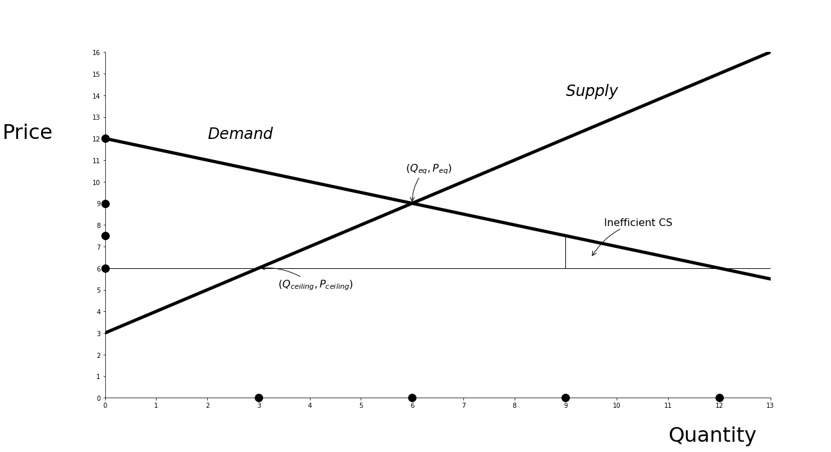
(b) The government decides that loans are too expensive and imposes a price ceiling of 6. If a price ceiling of 6 is imposed, what is the quantity traded in the market?
The supply curve determines the quantity, which is Q = 6-3 = 3.

(c) Suppose rationing is perfectly inefficient. Find the consumer surplus.
. For consumer surplus under perfectly inefficient rationing, first note that the controlled price of P = 6 gives Q = 24 - 12 = 12 on the demand curve and thus it is the consumers between Q=12 and Q = 9 who would get to buy the 3 units supplied. The price the consumer at Q = 9 on the demand curve is willing to pay is, from Q = 24 – 2P and P = 12 – Q/2 is 12 – 9/2 = 7.5. Thus, the consumer surplus is the triangle with area .5 (3) (7.5-6) = 2.25.

MULTIPLE CHOICE

1. Suppose the marginal cost of widgets is 3Q and the demand is P = 120- Q. Each widget imposes an externality of 2Q on neighbors because widgets make such loud noises. What is the surplus-maximizing quantity?
(a) Between 0 and 5.1.
(b) Between 5.1 and 10.1.
(c) Between10.1 and 14.1.
(d) Between 14.1 and 19.1.
(e) More than 19.1.
The marginal social costs of widgets is 3Q + 2Q = 5Q, so the optimal quantity is such that 5Q = 120 - Q and therefore Q = 20.

2. The real return on the S+P 500 from 1928 to 2018 was closest to which number?
(a) 3.1%
(b) 5.2%
(c) 8.4%
(d) 11.1%
(e) 14.0%

3. Suppose that at first there is efficient rationing under a binding minimum wage. If rationing becomes inefficient, how does surplus change?
(a) Employer surplus rises and worker surplus falls.
(b) Employer and worker surplus fall.
(c) Employer and worker surplus rise.
(d) Employer surplus falls and worker surplus rises.
(e) None of the above.
The employer surplus is unchanged, since so are the wage and number of workers hired. Worker surplus falls.

4. If nobody can sell lemons below a certain higher-than-market government-fixed price, one source of lost surplus is
(a) High-cost lemon producers can survive in the market.
(b) Some high-demand consumers may not be able to buy lemons.
(c) The market will be more easily monopolized.
(d) (a) and (b).
(e) None of these things will happen and reduce surplus.

5. Without regulation, which of the areas in the diagram of demand and marginal benefit are deadweight loss?
(a) A+C+D+E
(b) D+E
(c) B+E
(d) E
(e) E+H

CS = B-E. A+C+D are imaginary CS, that turns out not to exist.

6. Which concepts are associated with public goods?
(a) Nonrivalrousness
(b) Nonexcludability
(c) Positive externalities
(d) (a), (b), and (c)
(e) (a) and (b)

7. Regulatory capture refers to
(a) The regulation of essential industries.
(b) Regaining lost surplus via regulation.
(c) Mistaken regulation due to government incompetence.
(d) Control of a regulator by the regulated industry.
(e) All of the above.

8. Which kind of government regulation is most likely to fall prey to government failure? One with:
(a) Long-term costs and benefits.
(b) Short-term costs and benefits.
(c) Long-term costs and short-term benefits.
(d) Long-term costs being greater than long-term benefits.
(e) None of these things matter.

9. Which of the following is a major principle of administrative law?
(a) Opportunity for public comment.
(b) Transparency.
(c) Regulations being made by the executive branch.
(d) Judicial deference to the agency’s interpretation of regulations.
(e) All of the above.

10. Which type of official is most likely to be looking for a promotion to a job in
a different agency?
(a) A “careerist”.
(b) A “professional”.
(c) A “politician”.
(d) A “civil servant”.
(e) All of these are about equally likely.
Careerists look to a career in the one agency. Professionals are concerned about professional standards, not so much about what their bosses think of them. Politicians are looking to impress their bosses or voters and get a promotion somewhere else in government. All of them are civil servants.

11. The average rate of inflation from 1928 to 20018was closest to which number?
(a) 1%.
(b) 3%.
(c) 5%.
(d) 8%.
(e) 10%.

12. Apex’s marginal benefit from being able to create more fine-particle (soot) pollution is MBa = 40 - A if it is already creating A pollution. Brydox’s marginal benefit is MBb = 60-3B, where its output is B. The government is auctioning off 20 permits and these are the only two buyers. In equilibrium, how many permits does Brydox win in the auction?
(a) Zero to 5
(b) 6 to 9.
(c) 10.
(d) 11 to 15.
(e) 16 to 20.
At the equilibrium price, the marginal benefits of the two buyers are equal and 20 permits are sold. Thus we know
40-A = 60 -3B and A + B = 20.
Solving these together yields 40 - (20 - B) = 60-3B, so 40-20 + B =60- 3B so 4B = 40 and B = 10.

13. If a new regulation has a one-time cost of 12 million dollars and the discount rate is 5%, that is equivalent to what annual cost in perpetuity?
(a) Between 0 and .9 million dollars.
(b) Between .9 and 2.9 million dollars.
(c) Between 2.9 and 3.9 million dollars
(d) Between 3.9 and 4.9 million dollars.
(e) Above 4.9 million dollars.

14. Which of the following will increase the dollar value of a statistical life as measured by a hedonic regression?
(a) A fall in the discount rate.
(b) A rise in the discount rate.
(c) A fall in wages.
(d) A reduction in other risks in the economy.
(e) None of the above.
If the discount rate falls, people will value their future utility more in dollar terms, so they will require higher wages for dangerous jobs or lower prices for dangerous products.

