May 11, 2017. Then May 4, 2018.
3400 words

Published in RealClearDefense, May 12, 2017, but by 2018 the figures have all gotten unlinked on their site. They removed all my hyperlinks too, so this is a superior version in all ways.
https://www.realcleardefense.com/articles/2017/05/12/conventional_artillery_and_nuclear__missiles_in_north_korea_111363.html

Conventional Artillery and Nuclear Missiles in North Korea: A Game Theory Approach to Credible Threats

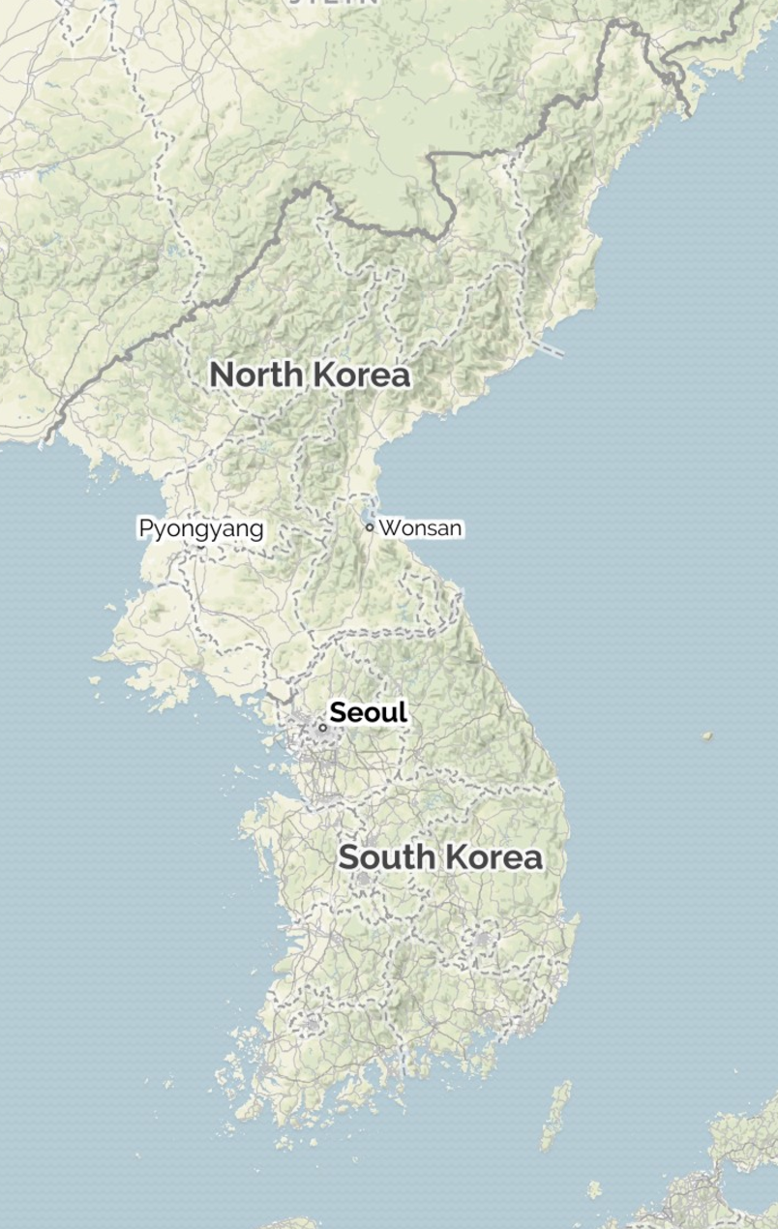
There has been much discussion of what a Second Korean War might look like. Would the North Koreans reach Seoul? What would South Korea do if it didn’t have U.S. ground troops to help? I think those are not the most important questions for us now. For Korea in 2017, we need to put the Korean War out of our minds and make a fresh start. We need to think not about the landing at Incheon or the Chosin Reservoir Campaign, but about the Cuban Missile Crisis and Dr. Strangelove. We need to enter the world of the ICBM, the Berlin’s trigger garrison, and mutually assured destruction.

I will argue that only a small part of the military picture in Korea is relevant: North Korean long-range artillery and the almost-ready nuclear missiles. I will show that the artillery is essential to North Korea for defense, but that it could be leveraged to have value for extortion by nuclear missiles. Hence, it is crucial for the United States, South Korea, Japan, and China to eliminate that threat by force or the threat of force.

North Korean once swept away South Korea’s army with ease and with China sent the United States military into headlong flight and then fought the counterattack to a standstill. Now, it’s a basket case. The economy is a wreck, the government is corrupt, the leader is a joke, and the citizens are the most oppressed people in the world. The army is still huge, but it could no longer defeat South Korea, not even if the United States army left. Fragile North Korea will not try an invasion, especially since the ideology of revolutionary Communism has slowly changed into a local Kim monarchy.

As a result, the North Korean army now has two purposes. The first is to enslave North Koreans. The other is to defend against South Korea. Invasion by South Korea is a real threat. Koreans are nationalistic. If unrest broke out in the North, it is easy to see how some might invite aid from South Korea. South Koreans want reunification, though it depends on the cost. The United States has overthrown governments in Iraq and Libya for human rights violations trivial compared to North Korea’s and has shown no qualms about violating national sovereignty in the interest of justice. So North Korea is right to be worried.

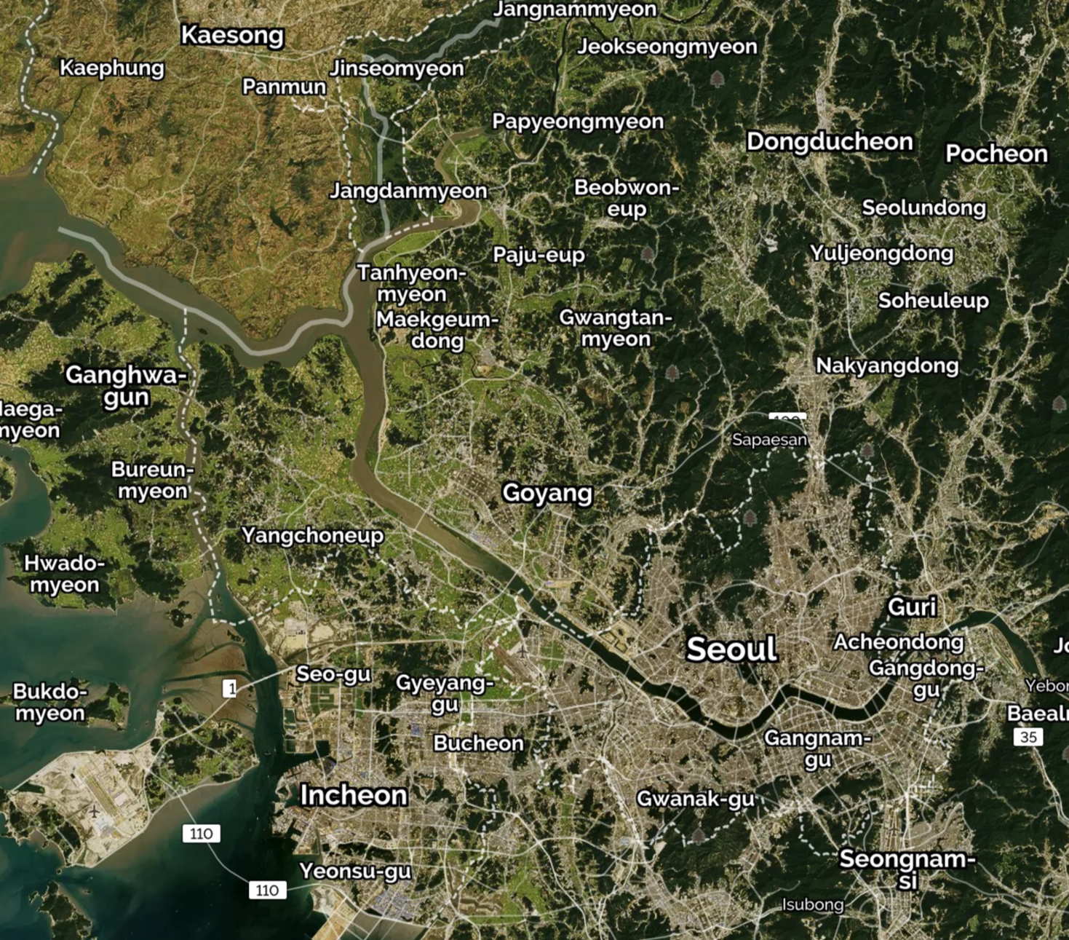
The North Korean army cannot win a war with South Korea (and the United States--- but I will just say “South Korea” when I mean the Korea-US alliance). What it can do is to make the invasion costly. That “Swiss strategy” is easier for North Korea than for Switzerland because Seoul is only about 25 miles from the border, within the range of long-range artillery and rockets. North Korean bombers can be shot down, and North Korean missiles can be intercepted, but artillery shells would be too numerous to stop.

Thus, North Korea’s best strategy is to put 100% of its artillery in the part of North Korea closest to Seoul, the Kaesong salient, and to put 100% of its infantry and armor there to protect the artillery. The function of the artillery is not to protect Pyongyang from a ground attack; it’s to kill people in Seoul. The function of the rest of the army is to delay the South Korean army’s advance a little while so the artillery can do its job.

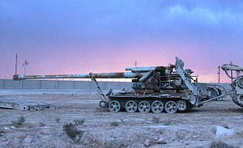
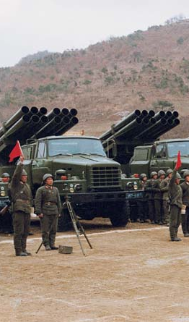
North Korea has 130mm and 170mm guns (5- and 7-inch) with ranges of 25 and 35 miles using special base bleed or rocket-assisted projectiles. The black arcs on the map show how far they can reach into South Korea. North Korea also has 122mm and 240mm multiple rocket launchers (5- and 9-inch), with about the same two ranges, and 300mm (12-inch) rockets that can reach 120 miles. Sources say that the array of 300mm rockets could hit Seoul with 350 metric tons of explosives in a single volley, about the same payload as 100 World War II Flying Fortress bombers. The vast arsenal of 170mm and 240mm weapons could fire an astonishing 10,000 rounds per minute. In addition, North Korea has SCUD and home-grown missiles--- larger and more intelligent devices than rockets--- but although their ranges are longer, they are less numerous. South Korea’s Patriot, Aegis, and now THAAD anti-missile systems can counter missiles, but would be overwhelmed by artillery shells and rockets. Artillery is relatively cheap and simple. It alsorequires less talent and training to use, especially when, as here, it is used like the old-style coastal artillery batteries that spent years training to hit targets in their individual harbors. These gunners don’t have to learn how to roll a barrage, or react to infantry calls for help, or read topographic maps. Rate of fire and concealment can be honed to perfection.

South Korea is well aware of the Kaesong artillery and has done its best to counter it with fire-spotting technology to locate and missile, air, special operations, and ground forces to eliminate it. I would not be surprised if every North Korean gun were destroyed within 24 hours after it revealed itself by firing. But 24 hours is too late. This is not battle, but terror, and a terror attack doesn’t have to last an entire day.

Besides defense, the North Korean military does have another purpose: to make money. Although it is unlikely the army could actually be made profitable on net, there are two ways it can help defray its own costs. One is arms sales. As a gangster state, North Korea has nothing to lose by engaging in criminal activities, and the government has no doubt decided that the nation’s top talent is better used for that than for industrial production. Such things as drug sales, internet crime, and arms sales to embargoed nations and terrorist groups are more lucrative than exporting shoes and T-shirts.

The army can also make money by extortion. North Korea’s army is too weak to engage in plunder by conquest, but it is strong enough to engage in demanding nuisance fees. Would it be worth $20 billion per year to South Korea to avoid Seoul being bomabarded? North Korea could be like the Barbary pirates of 1800, who were enough of a nuisance to extract a goodly amount of the their revenue as protection money, but so poor that that same amount was trivial to the European countries that paid it. The United States, having more principle and less monetary calculation, ironically, than the aristocratic Europeans, proved problematic on the shores of Tripoli and eventually France ended the game by conquering Algeria. But the Barbary pirates did have a good run for their money.

The problem is making the threat to bombard Seoul credible. The threat is credible if South Korea invades the North. If a South Korean invasion begins, and Kaesong is about to be occupied, North Korea has nothing to lose by destroying Seoul. If South Korea purposely bypasses Kaesong to avoid triggering that response, and heads straight for Pyongyang, the Kim regime would see its demise and, again, might as well destroy Seoul and get a bit of revenge. Either way, the threat of bombardment is credible.

On the other hand, if North Korea simply says it will shell Seoul unless $20 billion is deposited in a Swiss bank account, that threat is not credible. If South Korea refused, and North Korea shelled Seoul, South Korea could respond by destroying the guns. Once the guns were gone, South Korea could invade North Korea without fear of retaliation. North Korea will have shot its wad. South Korea may have lost 100,000 people, but that would be small comfort for the Kim regime if it lost power. Thus, looking ahead, South Korea can see that the North would not retaliate and the $20 billion demand can be safely refused.

Figure 1 depicts the situation as a game theory tree. Working back from the end, the player’s best choice at each point in time is indicated by an arrow. If Seoul has been bombarded, South Korea compares payoffs of -95 from invading and -100 from not invading, and will invade. If South Korea has not paid the $20 billion, North Korea will compare payoffs of -200 from bombarding Seoul (since South Korea will then invade) to -1 from not bombarding. If North Korea demands $20 billion, South Korea will compare payoffs of 1 from not paying and -20 from paying. Thus at the start of the game, North Korea compares payoffs of -1 from demanding $20 billion and 0 from not demanding. The equilibrium outcome is that North Korea does not demand $20 billion--- but that happens because the rest of the game tree is lurking in the background.

North Korea might imitate the Barbary pirates and makes smaller demands and smaller threats. It could demand $1 million and threaten just 5 minutes of bombardment, and that might work better. I will not go into that analysis. Just note two things. First, it seems that North Korea has not tried this (though if it has tried it, both countries would want to keep the deal secret), which is evidence that it doesn’t think the threat is credible. Second, this strategy is always dangerous, because things can go wrong by accident. A North Korean colonel might bombard for 10 minutes instead of 5, for example, because he gets distracted by a phone message like the accountant envelope-giver at the 2017 Academy Awards, and someone in the South decides this is an invasion, not a 5-minute shelling. The result would be invasion, and the Kim regime would have lost power, prosperity, and life in an operation with upside potential of just $1 million, a mere 6 months of cognac funding.

But let us turn to missiles and nuclear weapons. North Korea doesn’t need them for defense against the South. The Kaesong salient artillery is sufficient for that, and much cheaper. So what use are nuclear missiles?

First, nuclear missiles would be useful for deterring invasion by China. North Korean artillery cannot reach anywhere important in China, and China would not be impressed merely by the threat of killing some thousands of unimportant people near the North Korean border, many of whom would be ethnic Koreans anyway (many Koreans have lived on the Chinese side of the border in Manchuria for the past century). A missile that could reach Mukden or Beijing, however, would be a credible and painful threat.

Does North Korea need to fear invasion by China? Yes---but not much. China likes the status quo. On its border is a militarily weak Korea. Within its border, a small area of Manchuria is inhabited by ethnic Koreans and a large area of Manchuria was part of the Korean kingdom of Koguryo. Getting it back is a theme in some of the TV dramas that are such an important part of South Korean popular culture. In 2006’s Jumong, the title character unites factious Korean tribes to fight off Han China and found the Koguryo kingdom; in 2011’s Warrior Baek Dong Su, the warrior aids a crown prince who valiantly fights against Chinese dominance. I would not be surprised if that TV show were well known in China also, since Korean dramas are widely exported.

Modern democracies generally aren’t revanchist, but the very term recalls one that was--- Third Republic France, with its resentment for the loss of Alsace-Lorraine. It is prudent for China to maintain a weak neighboring Korea.

On the other hand, the status quo depends on the Kim regime preventing internal revolution. The day it becomes clear that the Kim regime might not survive, China will want to act. To prevent a revolution that might end up in a merger with South Korea or a prosperous North Korea, China would need to act, either by propping up the Kims or by pre-emptively replacing them with a Chinese puppet. A Korean nuclear threat would prevent that.

Nuclear weapons would also make possible a North Korean invasion of South Korea. North Korea is no match for South Korea at the moment, but tactical nuclear weapons could alter the balance. Tactical use of nuclear weapons--- that is, use to destroy troops in battle rather than cities or military bases--- has been a neglected subject because most countries would not accept the casualties, radioactivity, and horror of nuclear weapons merely to obtain a battlefield advantage. North Korea might be an exception. Nuclear artillery and missiles could neutralize U.S. sea power and cripple the South Korean military. This is such a high-risk strategy that it is hard to believe North Korea would do it--- but they surely would dream about doing it.

A second use motivation for nuclear weapons is profit. Foreign sales could by themselves make nuclear weapons worth developing. Indeed, one wonders why Iran doesn’t buy bombs from North Korea instead of making their own. More important for the discussion here, nuclear weapons add crucial leverage to the North Korean artillery threat. Imagine now that Kim has nuclear missiles pointed at Seoul. This changes the game from Figure 1 to Figure 2. There is now a new move at the end: A-Bomb Seoul, or Don’t Bomb. Many of the best-choice arrows change, however, because the A-Bomb move changes everything, even if it never comes into play. Now, if the South invades--- the last move of the old game--- the North responds with atomic weapons against Seoul, a calamity for both countries but at least yielding some measure of revenge for the North as the regime collapses. As a result, Seoul will not bomb Pyongyang and its threat to do so evaporates. If its threat to bomb Pyongyang evaporates, North Korea is free to bombard Seoul. Since North Korea now has a credible threat to bombard Seoul, South Korea will pay the $20 billion, and since South Korea will pay, North Korea will issue the threat that starts the whole process. Figure 2’s game tree illustrates this by assigning numerical payoffs to this story and putting arrows on each player’s best move at each decision node. At the end of the game tree, if the South has invaded, North Korea picks A-Bomb on Seoul with its payoff of -180 instead of Don’t Bomb with its payoff of -200. Foreseeing this, South Korea chooses Don’t Invade with its -100 instead of Invade with its -180. In that case, North Korea is willing to Bombard Seoul and get 2 instead of Don’t Bombard for -1. But if North Korea would bombard Seoul, South Korea will pay the $20 billion for a payoff of -20 instead of the -100 it foresees is the ultimate consequence of refusal. And so North Korea feels safe in demand the $20 billion, because it knows South Korea will pay, and 20 is better than 0. A single different move at the end of the game alters the result completely.

This is why nuclear missiles matter so much. They would matter even without the Kaesong salient artillery, because if the North had several reliable nuclear missiles, it could replace the artillery bombardment with one of them, saving the others for retaliatory backup. And North Korea could issue these credible threats not just to South Korea but to China and Japan. It is crucial, though, that North Korea have good enough missiles, not just the nuclear devices themselves. It cannot count on air force bombers, which could not get past South Korean fighters, and possession of artillery-fired nuclear warheads would merely strengthen the bite of the already-strong artillery. What North Korea needs is enough delivery range to keep its nuclear missiles safe from an initial rush by the South Koreans.

We could extend the game tree still further. North Korea must first acquire missile-delivered nuclear bombs and demonstrate that they work (or at least have a good shot at it). South Korea, the United States, Japan, and China all want to prevent that. I am surprised that China has not done so with economic sanctions. The reason may be that sanctions would weaken the Kim regime so much that it would fall, and China does not want that, so too strong a sanctions threat is not credible. Japan does not have the military strength to do anything except provide moral support. I don’t know about South Korea, but the United States does have the military reach to stop the nuclear program. This could be by bombing its manufacture, or by serious military action against North Korea in the form of bombing or infantry landings. Military action along the border is too risky; it risks accidentally triggering the Kaeson artillery. Seizure of a northern coastal city or bombing of some city or military target other than Pyongyang (again, too much risk of accidental response) would have minimal risk. Moreover, though the U.S. military would be horrified, the risk could be further minimized by announcing the time, date, and target of the attack. This would increase U.S. casualties, but it would be important for preventing full-scale war.

It is perhaps worthwhile to mention the optimal North Korean response to this credible threat of U.S. attack on nuclear weapon facilities. North Korea surely realizes as Hanoi did in the Vietnam War, that America’s strong point--- the rule of law--- is also her weak point. Presidents have four-year terms, limited to two terms. Bombing North Korea is an action with short-run costs and long-run benefits. Thus, if North Korea can persuade a President that it will delay its development of nuclear missiles until his term has finished, the President will be tempted to leave the problem to his successor. This seems to have happened with President Clinton in the 1990’s. Moreover, such a North Korean promise will ordinarily be credible, since North Korea wants to give the current U.S. President as much breathing space as possible. Now that we are in 2017, however, with the weapons well along the way to development, an eight-year horizon may be too long to use that strategy. Our President also is well situated to play what Nixon called the “Madman strategy”: pretend to be crazy enough to ignore costs and push ahead with violent responses on every possible occasion---for example, bomb Syria after a minor and possibly staged gas attack. Indeed, many liberals in America think President Trump is literally insane, as witness the confident declaration of 35 psychologists at Yale. Incomplete information is a big part of the situation, so let us leave it at that for now.

What are we to make of all this? My conclusion is that it would be in North Korea’s best interest to develop nuclear missiles, as a source of revenue from arms sales and extortion. The extortion would come from China, South Korea, the United States, and Japan, so it is in their best interest to stop North Korea from developing nuclear missiles. Either China or the United States--- and probably South Korea even without U.S. approval--- could do this by military action. Such action would be in gross violation of North Korea’s sovereignty, but nobody in the world would care about that. Which of the three countries should do it? They should all get together and talk to make sure everyone is on the same page. Which country does it depends on military ability and domestic political cost, on details that I personally don’t know enough about. It should be possible to reach agreement, however, with appropriate side-payments to compensate whoever has to bear the costs--- with Japan included in the side payments, if not the military strike. We can hope that North Korea will back down if presented with an ultimatum. If, contrary to its own interests, it does not, U.S. military action is necessary to prevent Figure 1 from turning into Figure 2, with its reversal of the strategic advantage. Thus, eliminating the North Korean nuclear missile threat is necessary not just in case of North Korean invasion, or because of sales to rogue countries, but to prevent North Korea from being able to make use of its existing capability of destroying Seoul.

The author is Eric Rasmusen, author of Games and Information: An Introduction to Game Theory. His father-in-law and mother-in-law were emigrants to Seoul from Pyongyang and Kaesong, respectively.

