Handout: The Vertical Angle Theorem (Feb. 23, 2022)

The Vertical Angle Theorem: The vertical angles of two intersecting lines are congruent.
Or:
The Vertical Angle Theorem: The opposite angles of two intersecting lines are the same size.

These are two ways to state the same theorem. The first way requires the reader to know what “vertical” and “congruent” mean.

Proof 1. Draw two intersecting lines and label the angles a, b, c, and d, so a and c are opposite angles.
We know that a and b are adjacent and add up to a straight angle, 180 degrees. Thus, b + a = 180.
We know tha c and b are adjacent and add up to a straight angle, 180 degrees. Thus, b + c = 180.
But that means that b + a = 180 = b + c.
If we subtract b from both sides, the equation remains true, so b + a – b = b + c – b, so a = c.
In the same way, a + d = 180 and a + b = 180, so a + d = a + b, so d = b.
Thus, the opposite angles are equal in size. Quod erat demonstrandum. 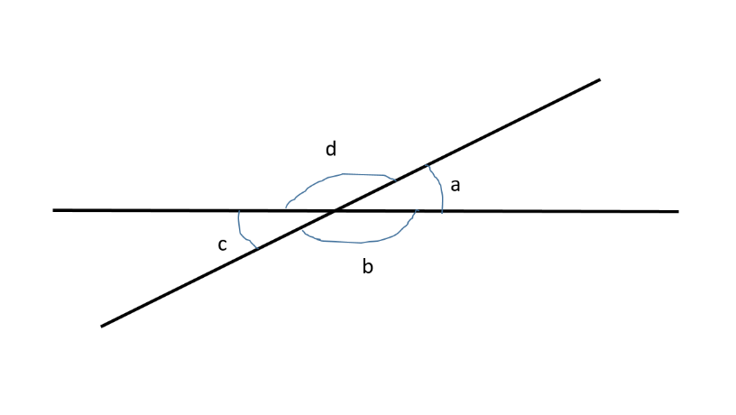

Proof 2. Draw two intersecting lines and label the angles a, b, c, and d, so a and c are opposite angles.
We know that a and b are adjacent and a equals the straight angle of 180 degrees minus b. Thus, a = 180 – b.
We know that c and b are adjacent and c equals the straight angle of 180 degrees minus b. Thus, c = 180 – b.
But that means that a = 180 - b = c, so a = c.
In the same way, b = 180 - a and d = 180 – a, so b = 180 - a = d, so b = d.
Thus, the opposite angles are equal in size. Quod erat demonstrandum.

Proof 3. There are other ways you can write the proof. A proof is a step-by-step explanation. Here is one that I like:
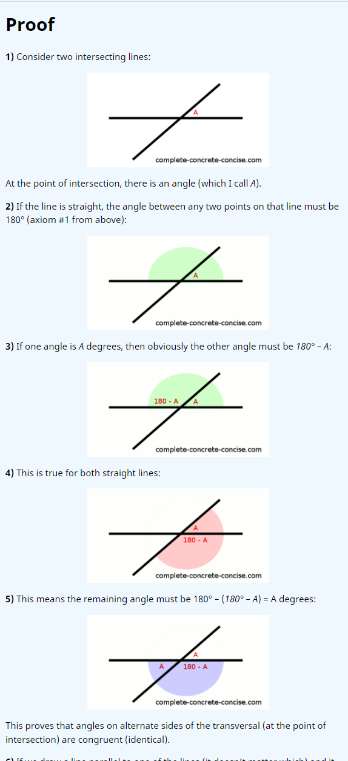
https://complete-concrete-concise.com/mathematics/proving-alternate-interior-angles-are-congruent-the-same/
#########################################################

