December 9, 2021

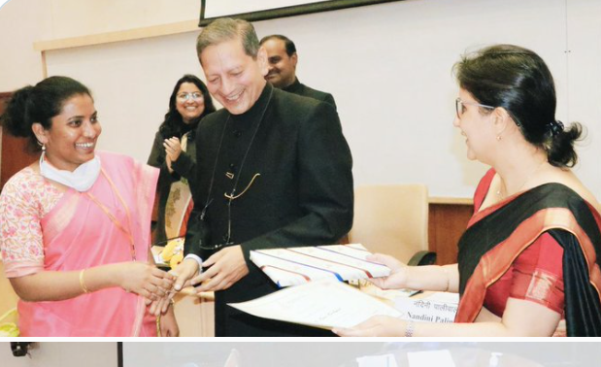

Anotherp oem: https://twitter.com/hephsyyy/status/1465654746874736651

Name HephizaH Korlapati.
https://www.gotquestions.org/Hephzibah.html : 2 Kings 21:1 and Isaiah 62:4. Translated from the original Hebrew, Hephzibah literally means, “My delight is in her.”

Economics in Bricks @econinbricks
What is the best academic writing tip you ever received?
10:57 AM · May 26, 2020·

Hephsiba R Korlapati IAS
May 26, 2020
Replying to @econinbricks and @AcademicChatter
Write with any quill. And Edit with full will.

Professor Eric Rasmusen
Jun 10, 2020
source? Or do I cite you, as this tweet? I am thinking of revising my Notes on Writing.

Hephsiba R Korlapati IAS
Jun 10, 2020
Replying to @erasmuse@econinbricksand @AcademicChatter
Yes Sir. It's original quote..

Professor Eric Rasmusen
Jun 10, 2020
Very good! It will go in the next draft of my APhorisms, if I ever get to it.

Hephsiba R Korlapati IAS
Jun 10, 2020
Sir, please share the same when You do

Professor Eric Rasmusen
Jun 10, 2020
Like to co-author the poem? Write first with any quill, Then edit with full will. To wait will paralyze-- But endlessly revise.

Hephsiba R Korlapati IAS
Jun 10, 2020
Good one Sir

Hephsiba R Korlapati IAS
Hectic months of writing and editing made #apromisedland. Keep #writing and #editing!!
"Write first with any quill,
Then edit with full will.
To wait will paralyze–
But endlessly revise."

@erasmuse
Sir &
@hephsyyy

1:24 PM · Mar 2, 2021·

https://twitter.com/hephsyyy/status/1366816640814342144

######################################################
"Work is Worship, Prayers in Rhyme. Praise & Worship, Yes, all the time!"

#####################################################
A Poem for January

"Sun, sun, stay this way;
Keep us happy all the day.
Not as striking as in May,
Now that winter's come to stay,
But you help us so to play."

Then I will show its evoluatoin rom Hep’s first two lines to the end.


Professor Eric Rasmusen@erasmuse
56m
"Sun, sun, stay this way; Keep us happy all the day."

Does anybody outside of Bangalore know this nice little poem?


Hephsiba R Korlapati IAS@hephsyyy
·54m
It's my original one I jotted this afternoon Sir.. with subtle edit by You. Thank You Sir

Professor Eric Rasmusen@erasmuse
38m
Ah-- very good. I thought somehow it was a well known children's poem there.

Hephsiba R Korlapati IAS@hephsyyy
25m
Another short rhyme jointly by @hephsyyy& @erasmuse
"Sun, sun, stay this way; Keep us happy all the day. Not too striking like in May, Just bright enough for our play." #HRK #JatayuSpeaks

Professor Eric Rasmusen@erasmuse
Further evolution:
"Sun, sun, stay this way; Keep us happy all the day. Not as striking as in May, Now that winter's come to stay, But you help us so to play."
4:52 PM · Nov 23, 2021·Twitter Web App

Valery, Paul ] Un poème n'est jamais fini, seulement abandonné.

