February 1, 2025

The Parallelogram Area Theorem: The area of a parallelogram is base*height.
Proof. The area of the parallelogram is Y + Z, so we have to show that Y + Z equals base*height.
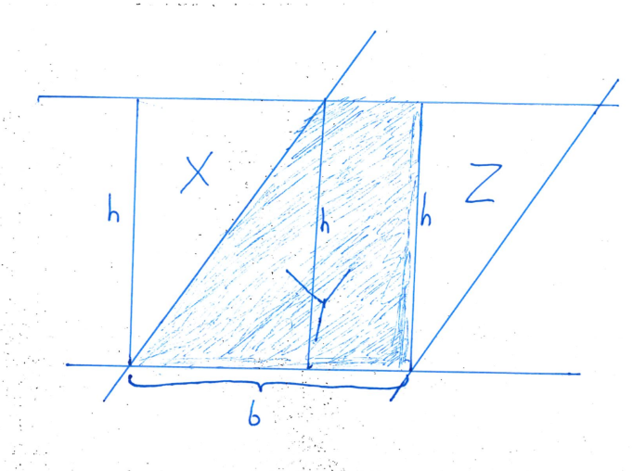

We know that X + Y is a rectangle, because it has 4 right angles. Since it is a rectangle,
X + Y = base*height.
But triangles X and Z are the same size, because they both have the same height, they both have a 90-degree angle, and their diagonals are the same length because the diagonals are two sides of a parallelogram. Thus,
X = Z
But if X = Z, then
X + Y = Z + Y,
so the parallelogram and the rectangle have the same area. Since the rectangle’s area is base*height, so must be the parallelogram’s.
Q.E.D.

