June 30, 2019
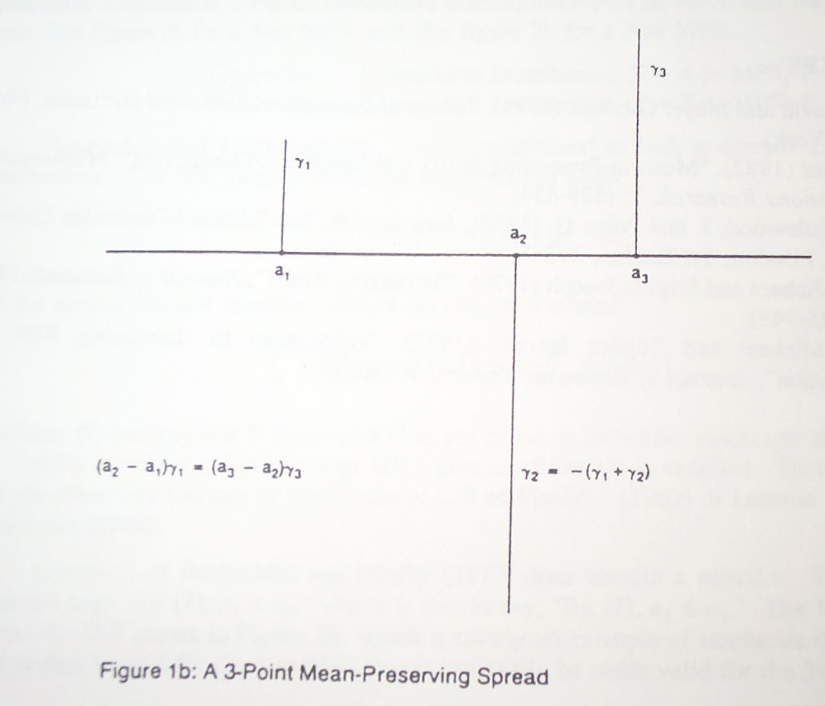
Eric Rasmusen
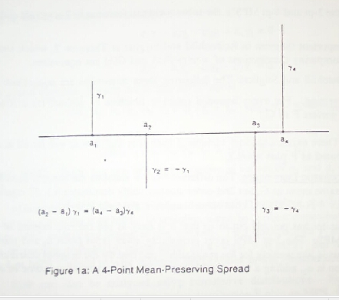

The Story of
“Defining the Mean-Preserving Spread: 3-pt versus 4-pt”
I thought I’d write up this story because it’s interesting and funny and gives a good idea of the flavor of academic life--- its international character, the difficulty of figuring out come up with what idea, and the publication process. It turns out to have more twists and turns that I’d thought, now that I’ve tried to look up all the references and follow the loose threads. Plus, this will give me an excuse to send "Concavifying the Quasi-Concave," "Option Learning as a Reason for Firms to Be Averse to Idiosyncratic Risk," "Splitting a Pie: Mixed Strategies in Bargaining under Complete Information," and "Back to Bargaining Basics" to lots of people for comment and circulation.

While I was at UCLA, around 1990, I was teaching Rothschild & Stiglitz (1970), the classic (4,817 cites as of 2019) Journal of Economic Theory (JET) article on mean-preserving spreads and risk definitions. They show that three things are equivalent about gambles X and Y: (a) anybody with a concave utility function prefers X to Y, (b) Y is X plus noise, and (c) Y is X plus a series of mean-preserving spreads of the outcomes, but it is NOT necessarily true that (d) Y has higher variance that X. This last is surprising. See my Rasmusen (2006) risk teaching notes in the references below for a numerical example.

I found a fatal flaw in their key proof. It's merely that in the middle of the proof they have a strong inequality where it should be weak, but it invalidates the entire proof approach. Their theorem is correct, though, and I suppose nobody ever looked at the proof carefully.

Their paper defines the mean-preserving spread as transferring probability from two points in the middle to two points further out in the density. I realized that the proof would work if the MPS were defined as transferring probability from ONE point in the middle to two points further out, but I couldn’t show that the two kinds of MPS had equivalent effects.


So I posted a flyer saying anybody who could do the proof could be my co-author. Econ Dept. grad student Emmanuel Petrakis (later to become a very successful professor at the University of Crete, with four 100+ cited papers as of 2019) figured out how to do the proof. We wrote it up and sent it to Rothschild and Stiglitz. Stiglitz never replied, but Rothschild wrote back with an exquisite combination of the positive and the negative, saying

“First, as far as I can tell, you are right, there is a glitch in our proof and it needs a fix like the one your [sic] propose. Second, I'm not sure what the paper adds to the literature. While the concept of a 3pt. MPS has some advantages over a 4 pt. MPS, they are equivalent and it is not clear to me which is more basic or intuitive. As Mark Machina has pointed out to me, perhaps the most basic and intuitive concept is due to Peter Fishburn (Simplest cases of n'th degree Stochastic Dominance" Operations Research Letters1, (1986) [Actually, it’s 1982] pp. 89-90. Finally, I seriously doubt the value of section 5 of your paper. I thought we made these points in our section IV (see in particular fn. 14) of our paper. Your proposition 2 is a trivial consequence of your and our Theorem 2 and is also stated in our paper.

Having said mostly nasty things, let me come to the real purpose of this letter which is to record my admiration and thanks for your marvelous text on game theory. The profession in general and this aging theorist in particular have needed such a book for a long time. Your tone, style and selection of topics strikes me as exactly right. Thank you!”

I should mention that despite the Rothschild-Stiglitz paper being a classic that is taught to pretty much every economics PhD student, some people grumble and say it shouldn’t have been published. The general math ideas in it were already in the mathematics literature, Hardy, Littlewood & Polya (1934) being the standard cite. Neither Rothschild nor Stiglitz (who won a Nobel Prize later) thinks like a mathematican--- they, like me, are truly economists, despite using mathematics in probably all of their work. Lots of people had written on stochastic dominance. Levy (1992) mentions four papers in top journals in 1969-70 that overlapped: Hadar & Russell (1969), Hanoch & Levy (1969), Rothschild & Stiglitz (1970) and Whitmore (1970). Everybody seems to have realized at the same time that “higher variance” is a bad way to define “riskier”, because someone with a concave utility function will actually welcome higher variance in some examples. See also David Schmeidler’s 1979 survey and the brief mention in Jonathan Levin’s good 2006 teaching notes (I see Levin is Dean of Stanford’s b-school now), and my 2006 risk teaching notes. Similarly, Peter Fishburn, a big name in operations research, had a 1982 paper in Operations Research Letters, “Simplest Cases of Nth-Degree Stochastic Dominance,” that did what Petrakis and I did in showing that 3-point and 4-point mean-preserving spreads were equivalent in vast generality--- but so vast that I don’t think anybody except Mark Machina realized it had anything to do with mean-preserving spreads. (I could be wrong, though; I’ve lost the paper and it isn’t on the web.)

Returning to the story, we submitted our note to JET. JET rejected, saying they didn't publish corrections. I don’t remember whether we submitted it elsewhere or not, but we probably did, because I have computer-file copies of submission letters to Econometrica, Journal of Finance, Journal of Risk and Uncertainty, and Economics Letters. Anyway, in 1992 we gave up and published in a conference volume, though to my surprise it’s gotten 10 cites by 2019 (including Blasco, Pin & Sobbrio (2016) of Bologna, Siena, and Lucca, and J. Whitmeyer & M. Whitmeyer (2019)--- the last cite apparently made just before I met econ grad student Mark Whitmeyer at a conference and was impressed by his paper on Bayesian elicitation in the Beer-Quiche Game, the other Whitmeyer being a sociology professor who works in one of the fields I’ve worked most in, rational-choice analysis of judges).

In 1999 I got an email from Dominique Thon in Macao telling me to look at a recent JET article, Leshno, Levy & Spector, JET, 1997. Titled “A Comment on Rothschild and Stiglitz's ``Increasing Risk: I. A Definition''”, it was about a *different* flaw in Rothschild & Stiglitz! (that the way they define MPS doesn't always meet the requirements for a cdf, so the proof is flawed.) I wrote back to JET, but editor Karl Shell said that though maybe we hadn’t been treated quite fairly, he didn't think it appropriate to mention our paper: "At any rate, the editorial board is unwilling to compound an error it might have made with printing Leshno et al."

Of course, maybe Petrakis and I were wrong in thinking that what we found was an error. Rothschild agreed that it was, but Stiglitz never wrote back to us, and it didn't get refereeing.

But the story continues. Another 1997 paper was the nice, clean, and complete Machina & Pratt (1997) in The Journal of Risk and Uncertainty, which tidied up the math in Rothschild & Stiglitz, taking things like Cantor sets into consideration. Pratt, at Harvard, is a very big name, the second name in the Arrow-Pratt measure of risk aversion. Machina, at U.C. San Diego, is a leading scholar on non-expected utility theories. Their acknowledgements list is impressive (my boldface—and I was just advocating on EconSpark for Groves to get a Nobel Prize):

“We would like to thank Persi Diaconis, Ted Groves, Josef Hadar, Walter Heller, David Kreps, Jack Meyer, Robert Nau, Joel Sobel, Shaun Wang, and Hal White for helpful comments on this material.”

Then something else was published. In 2000 Dominique Thon had pointed out another paper to me, a working paper by Rajat Deb and Tae Kun Seo at Southern Methodist University in Dallas. It looked like they’d come across the same idea Petrakis and I had of using a 3pt instead of a 4pt mean-preserving spread. I sent them our paper and they sent theirs to us, though I’ve lost it by now. In writing this up, though, I found it on the web--- published in 2011 as “Rothschild and Stiglitz’s Mean Preserving [sic]: Revisited,” in Social Choice and Welfare. It doesn’t cite us. I’ll write them and see what’s going on. Tae Kun Seo seems to have moved to the Korea Polar Research Institute in Inchon and to be doing work on various kinds of applications of math to science.

One more twist. Emmanuel Petrakis and I co-authored another paper, “The Learning Curve in a Competitive Industry,” that was published in the RAND Journal in 1997. This paper was quite visible and cited, and the working paper even got a footnote (I think) in Tirole’s Theory of Industrial Organization. That paper had a third co-author, Santanu Roy, one of Petrakis’s colleagues at Erasmus University, Rotterdam, when he was there. Petrakis and Roy went on to co-author another paper in 1999, “Cost‐Reducing Investment, Competition, and Industry Dynamics,’’ in The International Economic Review. Santanu also left Erasmus University, and is now University Distinguished Professor and Chairman of the Economics Department at Southern Methodist University.

References (in chronological order), Letters, and Emails

G. H. Hardy, J. E. Littlewood & G. Polya (1934) Inequalities.

J. Hadar & W. R. Russell (1969) “Rules for Ordering Uncertain Prospects,” The American Economic Review, 59: 25-34.

G. Hanoch & Haim Levy (1969) “The Efficiency Analysis of Choices Involving Risk,” The Review of Economic Studies, 36: 335-346.

Michael Rothschild & Joseph E. Stiglitz (1970) “Increasing Risk: I. A Definition,” The Journal of Economic Theory, 2: 225-243.

G. A. Whitmore (1970) "Third Degree Stochastic Dominance," The American Economic Review, 60: 457-459.

David Schmeidler (1979) “A Bibliographical Note on a Theorem of Hardy, Littlewood, and Polya,” The Journal of Economic Theory, 20, 125-128.

Peter C. Fishburn (1982) “Simplest Cases of Nth-Degree Stochastic Dominance,” Operations Research Letters, 1: 89-90.

Haim Levy (1992) “Stochastic Dominance and Expected Utility: Survey and Analysis,”Management Science, 38: 555-593.

Emmanuel Petrakis & Eric Rasmusen (1992) ``Defining the Mean-Preserving Spread: 3-pt versus 4-pt,'' in Decision Making under Risk and Uncertainty: New Models and Empirical Findings , edited by John Geweke. (http://rasmusen.org/published/Rasmusen_92BOOK.mps.pdf

Mark J. Machina & John W. Pratt (1997) “Increasing Risk: Some Direct Constructions,” The Journal of Risk and Uncertainty, 14:103–127.

Moshe Leshno, Haim Levy & Yishay Spector (1997) “A Comment on Rothschild and Stiglitz's ``Increasing Risk: I. A Definition'',” The Journal of Economic Theory, 77: 223_228.

Emmanuel Petrakis, Eric Rasmusen & Santanu Roy (1997) “The Learning Curve in a Competitive Industry,” The RAND Journal of Economics, 28: 248-268.

Emmanuel Petrakis & Santanu Roy (1999) “Cost‐Reducing Investment, Competition, and Industry Dynamics,’’ International Economic Review, 40: 381-401.

Jonathan Levin (2006) “Choice under Uncertainty,” Stanford teaching notes, https://web.stanford.edu/~jdlevin/Econ%20202/Uncertainty.pdf.

Eric Rasmusen (2006) “Lecture Notes on Risk, G601 Industrial Organization,” 27 September 2006, http:/rasmusen.org/zg601/overheads/09-risk.pdf.

Rajat Deb &·Tae Kun Seo (2011) “Rothschild and Stiglitz’s Mean Preserving [sic]: Revisited,” Social Choice and Welfare, 37: 659–668.

Andrea Blasco, Paolo Pin & Francesco Sobbrio (2016) ``Paying Positive to Go Negative: Advertisers’ Competition and Media Reports,’’ European Economic Review, 83: 243-261.

Joseph Whitmeyer & Mark Whitmeyer (2019) “Mixtures of Mean-Preserving Contractions,” University of Texas Economics and University of North Carolina-Charlotte Sociology working paper.

*****

``Defining the Mean-Preserving Spread: 3-pt versus 4-pt,'' Decision Making under Risk and Uncertainty: New Models and Empirical Findings , edited by John Geweke. Amsterdam: Kluwer, 1992 (with Emmanuel Petrakis ). ISBN: 0-7923-1904-4. The standard way to define a mean-preserving spread is in terms of changes in the probability at four points of a distribution (Rothschild and Stiglitz [1970]). Our alternative definition is in terms of changes in the probability at just three points. Any 4-pt mean- preserving spread can be constructed from two 3-pt mean-preserving spreads, and any 3-pt mean-preserving spread can be constructed from two 4-pt mean- preserving spreads. The 3-pt definition is simpler and more often applicable. It also permits easy rectification of a mistake in the Rothschild-Stiglitz proof that adding a mean- preserving spread is equivalent to other measures of increasing
risk. pdf (http://rasmusen.org/published/Rasmusen_92BOOK.mps.pdf

*****

Dear Professor Rasmusen:

I am responding with some delay to your letter of June 19thand the enclosed paper. I want to make three points: First, as far as I can tell, you are right, there is a glitch in our proof and it needs a fix like the one your propose. Second, I'm not sure what the paper adds to the literature. While the concept of a 3pt. MPS has some advantages over a 4 pt. MPS, they are equivalent and it is not clear to me which is more basic or intuitive. As Mark Machina has pointed out to me, perhaps the most basic and intuitive concept is due to Peter Fishburn (Simplest cases of n'th degree Stochastic Dominance" Operations Research Letters1, (1986) pp. 89-90. Finally, I seriously doubt the value of section 5 of your paper. I thought we made these points in our section IV (see in particular fn. 14) of our paper. Your proposition 2 is a trivial consequence of your and our Theorem 2 and is also stated in our paper.

Having said mostly nasty things, let me come to the real purpose of this letter which is to record my admiration and thanks for your marvelous text on game theory. The profession in general and this aging theorist in particular have needed such a book for a long time. Your tone, style and selection of topics strikes me as exactly right. Thank you!

Sincerely,

Michael Rothschild
Professor of Economics
Dean of Social Sciences

OUR RESPONSE: Fishburn does do it. We cite his 1982 paper. Both papers are for mathematicians, and one would not guess they were about MPS's unless one looked hard. We claim to have made the result intelligible by making it less general. The situation is similar to the origina R-S article, which some people would say was not orgiinal, but which was much clearer than its math predecessors and turned out to be very useful and influential.

*****

Dear Rajat,
Thank you for sending me your paper with Tae Kun Seo. I'll send along a copy to Emmanuel in Crete. We of course did not expect you to be aware of publications in old conference volumes, and we are gratified that you too think the idea of 3-point MPS's is useful. We do have the paper up on the web, knowing it is hard to get the original, at
http://Pacioli.bus.indiana.edu/erasmuse/published/92BOOK.mps.pdf
which may be helpful if your co-author is not at SMU.
I'm busy preparing for a seminar here next week, but I look forward to reading your paper.
Yours truly,
Eric Rasmusen
Olin Senior Research Fellow, Harvard Law School (2000-2001)
Professor of Business Economics and Public Policy and Sanjay Subhedar
Fellow, Kelley School of Business, Indiana University
Erasmuse@law.harvard.edu
Http://Php.Indiana.edu/~erasmuse
Office: (617) 496-4878. Home: (617)576-2182. Fax:(617)496-6118.
153 Upland Road, Cambridge, Mass. 02140
*****

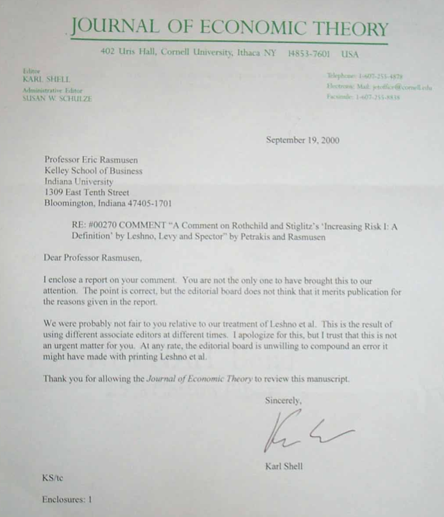

*****

My friend and co-author on two of those papers, Christopher Connell, will be terribly embarassed, but I’m trying to teach him to circulate his work despite his mathematician’s modesty about ever hinting that someone might like to read what he’s written. In economics, we know that the Axiom of Free Disposal is not just an assumption but an empirical reality when it comes to paper goods.

