September 16, 2020
This file consists of various facts and quotes and links used in the Ramseyer-Rasmusen article on the CDC.

President Trump put together a coronavirus task force headed by the obvious candidate Alex Azar. The CDC assured the task force that testing was well in hand, so it typically devoted only five or ten minutes of its often contentious meetings to that subject.

CDC Deputy Director Dr. Anne Schuchat said she didn’t think “we needed somebody else’s test.”

The FDA went so far as to ban everybody else’s tests: using the WHO test in America was illegal. In fact, the government made it even less legal to develop new tests than in ordinary times. Azar had issued an emergency declaration which allowed the FDA to speed for-profit test approval with “emergency use authorization”, but banned new tests developed by hospitals and laboratories for internal uses that previously were unregulated.

Stanford University researchers had a working test by February based on WHO’s test, 250,000 of which had already been delivered worldwide. But they gave up on trying to get FDA permission to use it. Biomérieux, a French company, had the same problem. The FDA just wouldn’t approve their test without weeks of discussion.

It was even illegal to use a test that exactly copied the CDC test--- a hospital still had to go through the rigorous FDA validation process to prove that its test really was the same as the CDC’s, not just pretend.

Professor Alex Greninger of the University of Washington in Seattle (where many of the first cases in America were discovered) tried to get his CDC-copy test approved by the FDA and failed. One FDA reviewer complained that Greninger hadn’t proved that his test wouldn’t show a false positive result if it were used on someone infected not with Covid-19 but with SARS or MERS, two viruses that were related to Covid-19 but which had a grand total of two cases ever recorded in the United States in the past twenty years. Professor Greninger told a reporter, “I think it makes sense to have this regulation when you’re going to sell 100,000 widgets across the U.S. That’s not who we are.”

Dr. Nancy Messonnier, Director of the CDC’s National Center of Immunization and Respiratory Diseases, said, “We obviously would not want to use anything but the most perfect possible kits.”

The CDC recalled all its tests. It told laboratories and hospitals to wait till the test was fixed. And as it worked on improving the test, it said that only people who had traveled to China or been in contact with some who had the virus should be tested, since it didn’t have the capacity for more testing than that.

By February 28, we had only 15 confirmed cases, a dozen of them travel-related, with 45 more from people returning from abroad for treatment having gotten sick somewhere else.

If we tested nobody at all, our statistics would be even better--- perfect!--- a bureaucrat’s victory dream, like the hospital in the British comedy, Yes Minister, that ran smoothly because it had no patients to get in the way.

In March, Harvard professor Marc Lipsitch said that China’s Guangdong (Kwangtung, Canton) province tested 300,000 people in fever clinics to find about 420 positive cases and overall, Guangdong had more than 1,000 confirmed cases, but “If you don’t look, you won’t find cases.” As Janet Hamilton at the Council of State and Territorial Epidemiologists said, “The disease is moving faster than the data.”

One health department official said Mr. Azar was repeatedly assured that the CDC’s test would be widely available within a week, only to be given the same promise a week later.

Supporters of Mr. Azar’s said he was told by Dr. Redfield that the CDC was on top of things--- that the coronavirus wasn’t spreading from person to person within the United States so widespread testing would be unwise.

Mr. Azar felt uneasy despite the advice he was getting, even though he knew that he could defend his testing policy by saying he had “empowered and followed the guidance of world-renowned U.S. scientists.”

After all, Dr. Nancy Messonnier, his career civil service subordinate and expert, was saying February 21st, “We’re fully stood up at CDC,” and “There is no lag time for testing.”

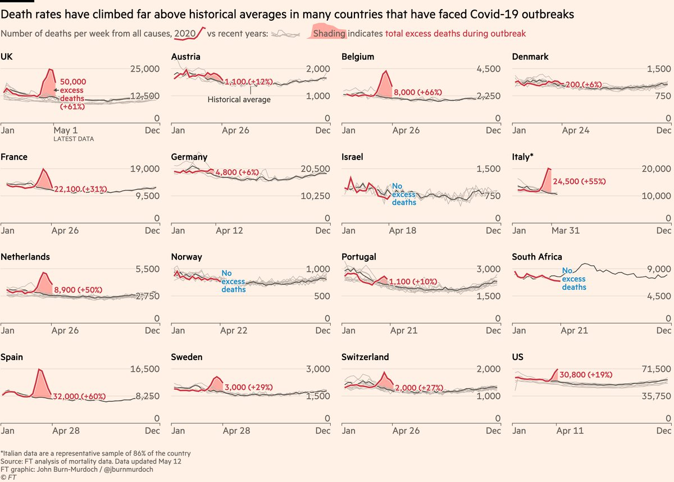https://www.ft.com/content/a26fbf7e-48f8-11ea-aeb3-955839e06441

The CDC’s Dr. Redfield was “a consensus person,” one colleague said, someone who sought to avoid conflict with agency staff.

He, like his boss Secretary Azar, relied heavily on CDC career civil-service scientists such as Dr. Anne Schuchat and Dr. Messonnier.

. There was a letter from 49 members of Congress about the lack of testing, to which he responded on February 24: “CDC’s aggressive response enables us to identify potential cases early and make sure that they are properly handled.”

It came to a head on February 26, when out of the blue, President Trump fired Mr. Azar as head of the coronavirus task force and put Vice-President Mike Pence in charge. Suddenly, things sped up. The next day there was a noontime conference call of CDC, FDA, and HHS headquarters officials. Brian Harrison, Mr. Azar’s chief of staff, began with an ultimatum: No one leaves the phone till we resolve the lag in testing. By the end of the day, it was agreed that the F.D.A. should loosen regulations on hospitals and independent labs.

The CDC and FDA told state and local health department labs they could also just starting using the first two parts of the CDC test kits and leave out the problematic third part for mutations.

Stanford had its test approved. Biomérieux had to wait more weeks, till March 24, though as early as March 12 the FDA started issuing Emergency Use Authorizations to commercial test companies too. A few days later, the FDA announced a new policy that allowed state public-health laboratories to authorize tests at other labs without any federal approval.

But in early February, a week after Korea’s first case was diagnosed, the government held a meeting of twenty medical device companies.

It told them it wanted Covid-19 tests, quick, for mass production, and it promised emergency approval.

Within two weeks, thousands of test kits were shipping each day, even though there were still less than 100 diagnosed cases. By March 23, Korea had over 300,000 tests, a rate per capita more than forty times America’s.

In 2019, South Korean biotech firm SolGent produced 300,000 medical test kits. One of five companies with fast-track approval for Covid-19 tests, by the end of March it was churning out 400,000 tests per week. It would even have exported them to the U.S., except that the FDA blocked it.

The Foreign Minister said, “Testing is central because that leads to early detection, it minimizes further spread and it quickly treats those found with the virus... the key behind our very low fatality rate.”

Besides developing test kits, the Korean government put them into use. They opened 600 testing centers, including 50 drive-through stations at which patients were tested without leaving their cars, rolling down their windows to get a nasal swab. Relentless public messaging told everyone to get tested if they had symptoms, or even if they crossed paths with someone sick.

They made a phone app that can shoot out notifications whenever a new case is discovered near someone.

Offices, hotels and highrises often used thermal image cameras to detect people with fevers coming in.

Korea did have an important advantage over most countries, though: a big Middle East respiratory syndrome (MERS) scare in 2015 that killed 38 people.

After that they revised their laws to prioritize national health over individual privacy.

By April 28, the U.S. had administered about 5.5 million tests, compared to just 617,000 for South Korea. Even in per capita terms, the U.S. had caught up and passed South Korea: it had 17,000 tests per million people, compared to 12,000 in Korea.

Alaska requires restaurants to keep a log with every customer’s name and phone number for 30 days in case it’s needed for tracing. And private businesses are taking precautions.

Georgia’s Madison Chop House Grille puts big blue X marks on certain tables and removes the chairs to let diners know they couldn’t sit there. Employees not only have to take their temperatures before they start work; it’s recorded on a white board to reassure customers. Tony Gore’s Smoky Mountain BBQ & Grill in Tennessee requires not just employees, but diners, must have their temperatures checked. The manager reports that though they were worried customers might think it was weird, nobody has objected.

Ask how many Covid-19 tests have been done, and the CDC can’t help. You can’t even get a daily update on how many people are getting hospitalized for Covid-19. The CDC wasn’t collecting that data in 2019, For four weeks, the CDC took weekends off from reporting any data at all on the epidemic, until political pressure forced it to ruin its employees’ Saturday afternoons.

In 2009, the federal government used up ¾ of its N95 masks for a flu epidemic. They weren’t replaced by either Obama or Trump.

There were many government reports 2003-2015 warning that there would be too few ventilator machines if an epidemic hit. It was obvious even without formal study.

In 2006, after an avian flu scare, Gov. Arnold Schwarzenegger had California spend $200 million on three 200-bed mobile hospitals and 50 million N95 masks, 2,400 ventilators, assembly kits for 21,000 beds in amphitheaters, etc. In 2011 Gov. Jerry Brown cancelled all that to save $5.8 million/year in maintenance. In 2020, California’s Public Health Dept. said it had 21 million masks but it wouldn’t release them for Covid-19 because they were past expiration date.

This is the usual outcome when you ask a two-handed economist for policy advice.

For many years, conservative critics have been calling out the CDC for how little of its effort is actually devoted to controlling disease. It was founded to control malaria; what it does nowadays is spend money on anything vaguely related to health. It’s problem isn’t lack of money. Its budget grew from $1.3 billion in 1987 (measured in 2019 dollars) to $7.3 billion in 2019, considerably faster than government spending in general.

It had big spikes in spending after the 2001 anthrax attacks and the 2005 avian flu scare. The CDC can’t afford to keep an aerial ‘bio-containment unit’ on retainer, but it does have a museum and lots of other dubious spending, as detailed in a 115-page report in 2007 from Senator Coburn’s office.

Of its 2019 budget, by our count, just 64% is spent on epidemic control, broadly defined---Immunization and Respiratory Disease; Public Health Preparedness and Response; Public Health Scientific Services; Emerging and Zoonotic Infectious Diseases; HIV/AIDS, Viral Hepatitis, STI and TB Prevention; and Global Health. If we define epidemic control more narrowly to include just the first three, only 31% is spent on epidemic control.

The CDC is also spending billions on Chronic Disease Prevention and Health Promotion, Birth Defects; Enviromental Health, Injury Prevention and Control, and Occupational Safety and Health, large sums on problems that have nothing to do with epidemics--- such things as alcoholism, smoking, traffic accidents, sports injuries, wife beating, and gun control.

Even though it was clear from the start that vaping lung injuries overwhelmingly involved illegal cannabis products, the CDC kept insinuating that legal, nicotine e-cigarettes could kill you. This kind of fraud did the CDC’s credibility no good.

Back in 2014, Nick Gillespie wrote a 2014 article for Reason magazine titled, “Hey CDC: `You have one job. Try doing it.’ " We need a single-purpose agency for dealing with epidemics.

In 2019 Congress passed the Pandemic and All-Hazards Preparedness Act. J. Glock has assembled an impressive list of pandemic plans. in City Journal, noting that, “The problem isn’t that the U.S. government lacked a plan for an international pandemic. It’s that the government had dozens of such plans, totaling thousands of pages.” Glock proceeds to list the National Strategy for Pandemic Influenza, the fifty Pandemic Preparedness Plans of the states, the Biological Incident Annexes to the National Response Frameworks, the HHS Pandemic Influenza Plan, the National Health Security Strategy, the WHO-initiated United States Health Security National Action Plan and North American Plan for Animal and Pandemic Influenza, the National Biodefense Strategy, and the National Security Council’s Playbook for Early Response to High-Consequence Infectious Disease, and the Pandemic Crisis Action Plan.

